**RETAIL CERTIFICATION NOTES**

1. What do you mean by retail and retailing?

* Retail involves the sale of goods from a single point (malls, markets, department stores etc) directly to the consumer in small quantities for his end use.
* Retailing – buying large amt of goods from manufactures/wholesalers and selling in terms of individual quantities.

1. Who is a retailer?

Party which sells the goods

1. Which is the fastest growing segment of retailing?

Non brick and mortar retailing ie., online retailing – e-commerce and m-commerce (commerce used for B2C business to consumer ) transactions, mail order etc.

1. History of retailing ?

Brick and Mortar 🡪 Catalog, Mail and phone 🡪 Web (eCommerce) 🡪 Mobile (mCommerce) 🡪 What’s next?

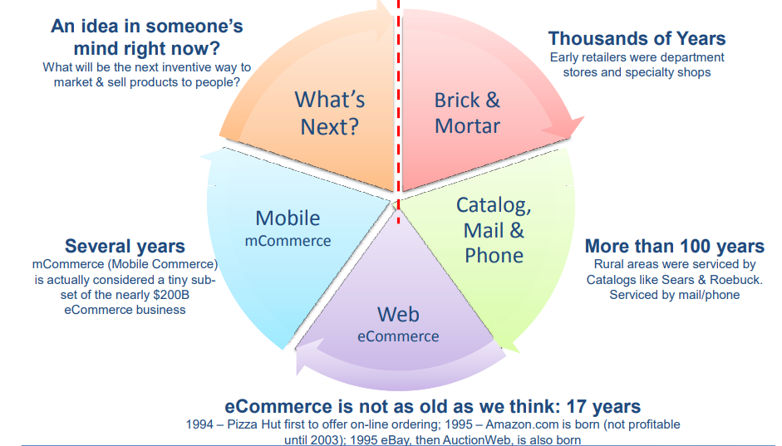

1. Which are the major components of the retail industry?
2. Item

Types :

1. Durable items – Car, Motor etc.
2. Non durable items – Food etc.
3. Catalog items – Organized, detailed, descriptive list of items arranged systematically.
4. Manufactures

Produces the product and sells to vendors or directly to retailers. (In house products are created by retailers itself.)

1. Vendors (Suppliers) – merchandise and non merchandise vendors

Person or company providing merchandise or service to a retail store. Manufacturers, wholesalers, distributors and service providers can all be vendors.

1. Warehouses

Gets product from vendors and sells to retail stores.

1. Stores
2. What is a supply chain ?
3. What is Supply Chain Management?
4. Define shopping.

Process of purchasing of products by consumer.

1. What are the basic terminologies of retail industry?
2. Retail chain / Chain store
3. Distributor
4. Distribution channel
5. Store/shop
6. Mercantile establishment/outlet/retail store/sales outlet
7. Department store/Emporium
8. Marketing
9. Discount house/discount store/discounter